Table of Contents
1. Project Description 3
2. Application Used 4
3. Mapping PDC Concepts to Project 4
4. Module-by-Module Explanation 5
4.1 url_queue.cpp (The Buffer) 5
4.2 crawler.cpp (The Coordinator) 5
4.3 parser.cpp (The Task Generator) 5
4.4 saver.cpp and logger.cpp 5
5. Error Handling and Robustness 6
6. Full Code Listing 6
6.1 url_queue.h and url_queue.cpp 6
6.2 crawler.cpp 7
6.3 parser.h and parser.cpp 7
6.4 saver.cpp and logger.cpp 8
7. Execution 9
7.1 Normal Execution 9
7.2 Output Results 10
Page_1.html 10
Page_2.html 10
Page_3.html 11
Page_23.html 11
Directory View 11
8. Error Scenario 12
9. Contribution Table 14
10. Conclusion 14

Project Description
This project involves the development of a multithreaded web crawler designed to traverse the internet, download web pages, and extract links in a parallel environment. By utilizing a Worker-Pool architecture, the system demonstrates how parallel computing can overcome network latency and significantly improve the speed of data-intensive tasks compared to traditional serial processing.
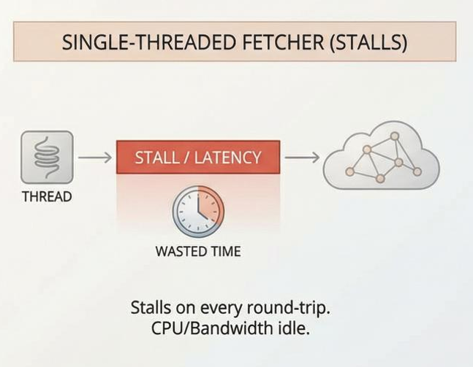
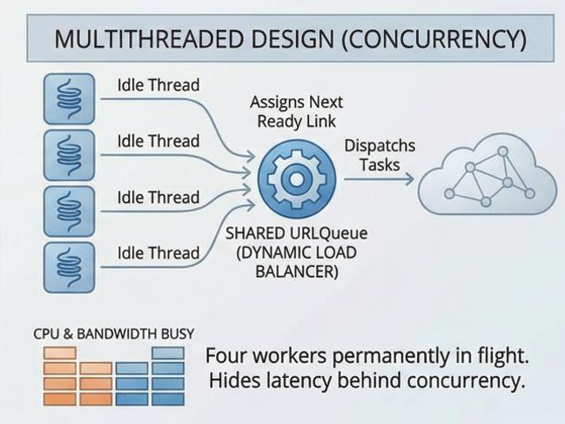

Application Used
The application is a command-line tool built in C++ that takes a "Seed URL" and recursively visits all links within the same domain.
- Purpose:
To automate the collection of web data for indexing or analysis.
- Architecture:
It uses a Producer-Consumer model where threads act as consumers of URLs and producers of newly discovered links.
- Environment:
Developed and tested on Kali Linux using the libcurl and pthread libraries.

Mapping PDC Concepts to Project
This project serves as a practical implementation of several core PDC pillars:
- Multithreading (Concurrency):
The program spawns’ multiple threads using pthread_create. Each thread operates independently, allowing for multiple simultaneous HTTP requests.
- Shared Memory Model:
All worker threads access a single instance of URLQueue and a visited set. This demonstrates the "Shared Memory" architecture where coordination is required to prevent data corruption.
- Synchronization (Mutexes):
To protect shared data, we implement Mutual Exclusion. For instance, in url_queue.cpp, a pthread_mutex_t ensures that only one thread can modify the queue at a time, preventing "Race Conditions."
- Condition Variables:
Instead of "Busy Waiting" (which wastes CPU cycles), threads use pthread_cond_wait to sleep when the queue is empty and are woken up via pthread_cond_signal when new links are found.
- Load Balancing:
The URLQueue acts as a dynamic load balancer, distributing the workload (URLs) to whichever thread is currently idle.
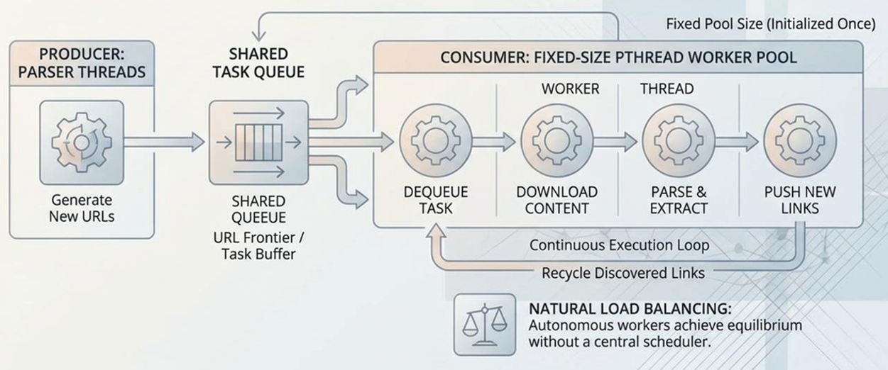

Module-by-Module Explanation

4.1 url_queue.cpp (The Buffer)
- Function: Manages the list of URLs to be visited.
- PDC Role: It is a "Thread-Safe" data structure. It uses locks to ensure that if two threads try to grab the same URL, only one succeeds, and the other is redirected to the next available task.

4.2 crawler.cpp (The Coordinator)
- Function: Handles the main logic, including the worker function.
- PDC Role: Implements the life cycle of a thread. It manages the global MAX_PAGES limit and ensures that all threads shut down safely when the goal is reached.

4.3 parser.cpp (The Task Generator)
- Function: Scans HTML code using Regular Expressions to find tags.
- PDC Role: This represents Data Decomposition. It breaks down a large webpage into smaller "tasks" (new links) to be fed back into the parallel system.

4.4 saver.cpp and logger.cpp
- Function: Save HTML files and log activities.
- PDC Role: These modules demonstrate I/O Synchronization. Because the file system is a shared resource, these modules use mutexes to prevent different threads from writing to the same file simultaneously.

Error Handling and Robustness
Error Situation | Handling Mechanism | Program Response
Network Timeout | CURL return codes check | Logs "Download failed" and the thread moves to the next URL.
External Links | Domain validation logic | Skips URLs that don't match the starting website to prevent infinite crawling.
Race Conditions | Mutex locking (pthread_mutex_lock) | Threads wait their turn to access shared variables, ensuring data integrity.
Empty Queue | Condition Variables | Threads go into a sleep state to save system resources until new work appears.

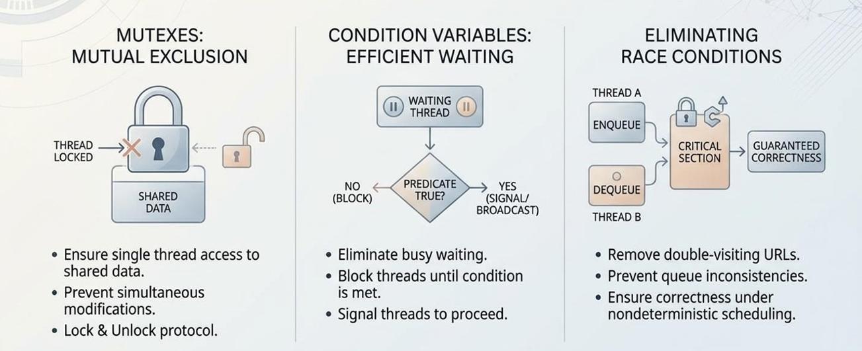

Full Code Listing

6.1 url_queue.h and url_queue.cpp
This module acts as the Shared Buffer. It is the most critical part of the project because it allows multiple threads to share a "To-Do list" without crashing.\
- URL Queue() (Constructor): Initializes the Mutex Lock and the Condition Variable. This prepares the "safety equipment" before any threads start running.
- enqueue(url, depth):
  - Locking: It first grabs the Mutex lock so no other thread can touch the queue.
  - Production: It pushes the new URL into the queue.
  - Signaling: It calls pthread_cond_signal to wake up any worker thread that might be "sleeping" because the queue was empty.
- dequeue():
  - Waiting (The Monitor Pattern): If the queue is empty, it uses pthread_cond_wait. This is better than a loop because the thread "sleeps" and consumes zero CPU power until it's woken up.
  - Consumption: Once a URL is available, it grabs the item, removes it from the queue, and unlocks the Mutex.
  - isEmpty(): Provides a thread-safe way to check if tasks are remaining by locking the Mutex during the check.

6.2 crawler.cpp
This is the Orchestrator. It manages the thread lifecycle and the actual network communication.
- write_callback(): A helper function for the libcurl library. It acts as a bridge between the internet data and our C++ strings.
- download_page(url):
  - Handles the HTTP request. In a parallel system, this is where the speedup happens. While one thread is "blocked" waiting for a website to respond, other threads stay busy.
- worker():
  - This is the main loop for every thread.
  - It pulls a URL from the urlQueue, checks if it has been visited (using visited_lock), and if not, proceeds to download and parse it.
- main():
  - Thread Spawning: Uses pthread_create to start 4 identical worker threads.
  - Barriers: Uses pthread_cond_wait at the end to keep the main program alive until the threads finish their work or the MAX_PAGES limit is hit.

6.3 parser.h and parser.cpp
This is the Task Generator. It breaks down downloaded data into new work.
- extract_links(html, base_url):
  - Uses Regular Expressions (Regex) to find every link ( tag) in the HTML code.
  - This demonstrates Data Decomposition: taking one large file and breaking it into many small "tasks" (links).
- join_url(base, path):
  - Error Handling: It fixes "Relative Links." If the crawler finds /page2.html, this function fixes it to https://site.com/page2.html. This ensures the worker threads don't try to visit invalid addresses.

6.4 saver.cpp and logger.cpp
These modules handle Shared Resource Output. Since the screen, the log file, and the hard drive are shared by all threads, we must protect them.
Functionality Explanation:
- save_page(html):
  - Mutual Exclusion: It locks save_lock before checking the page counter.
  - Atomic Increment: It ensures that stats.saved_pages++ happens safely so that page_1.html and page_2.html are never overwritten by two threads at once.
- log_message(msg):
  - Synchronization: Every time a thread wants to write to crawler.log, it must "grab the key" (the lock).
  - Timestamping: It adds the current time to every log entry so we can track the exact order of parallel events.

Execution

7.1 Normal Execution
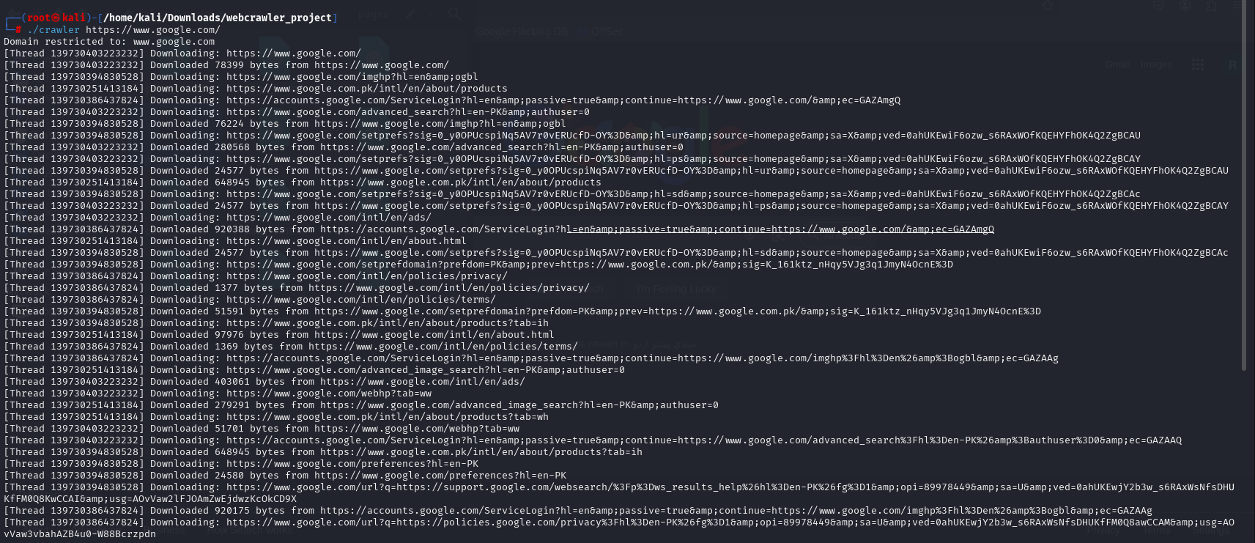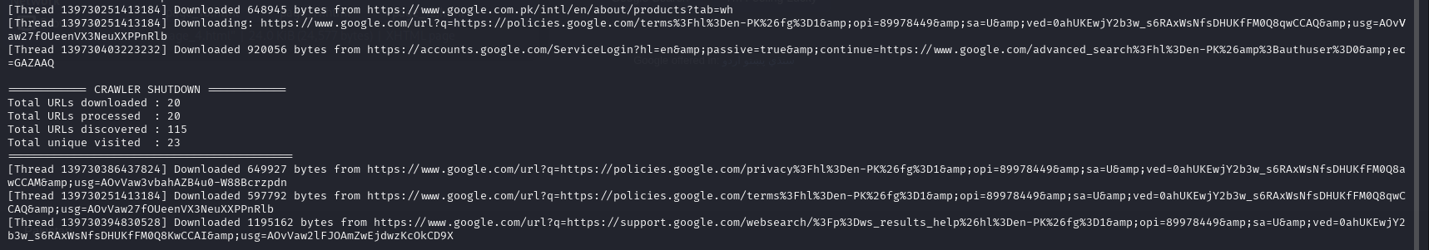
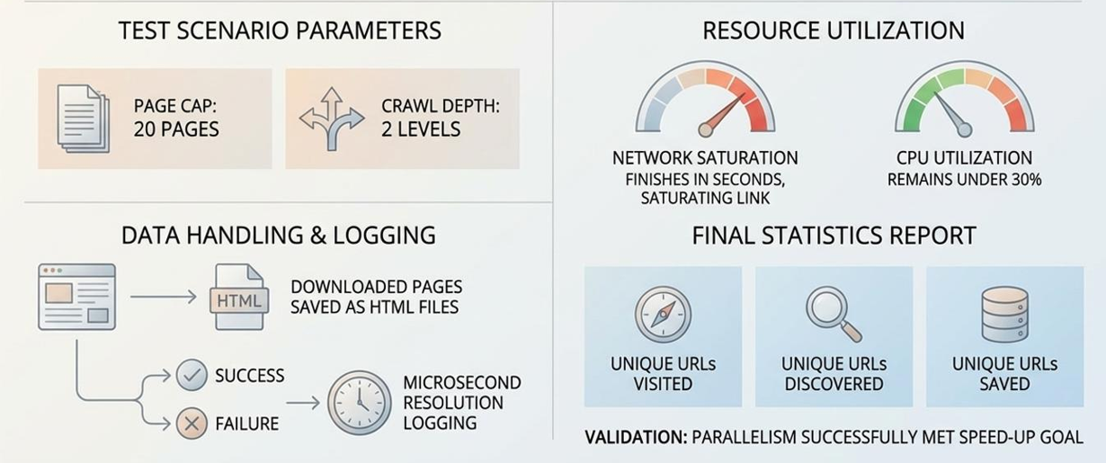

7.2 Output Results

Page_1.html
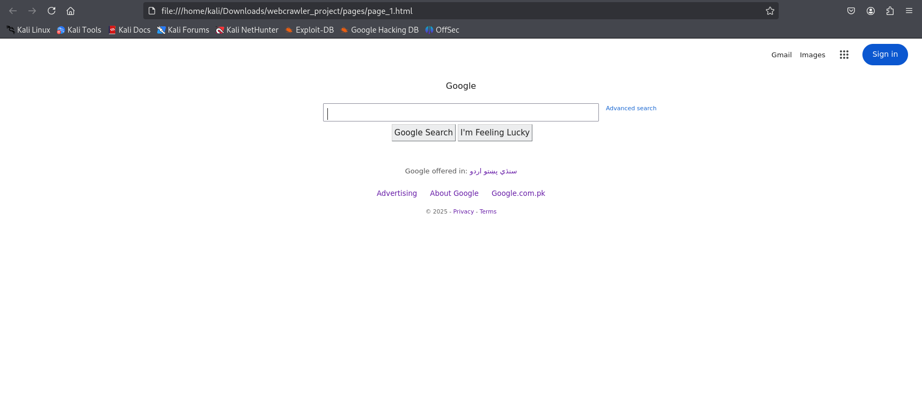
Figure 1 The "Seed" page successfully retrieved from the initial URL.

Page_2.html
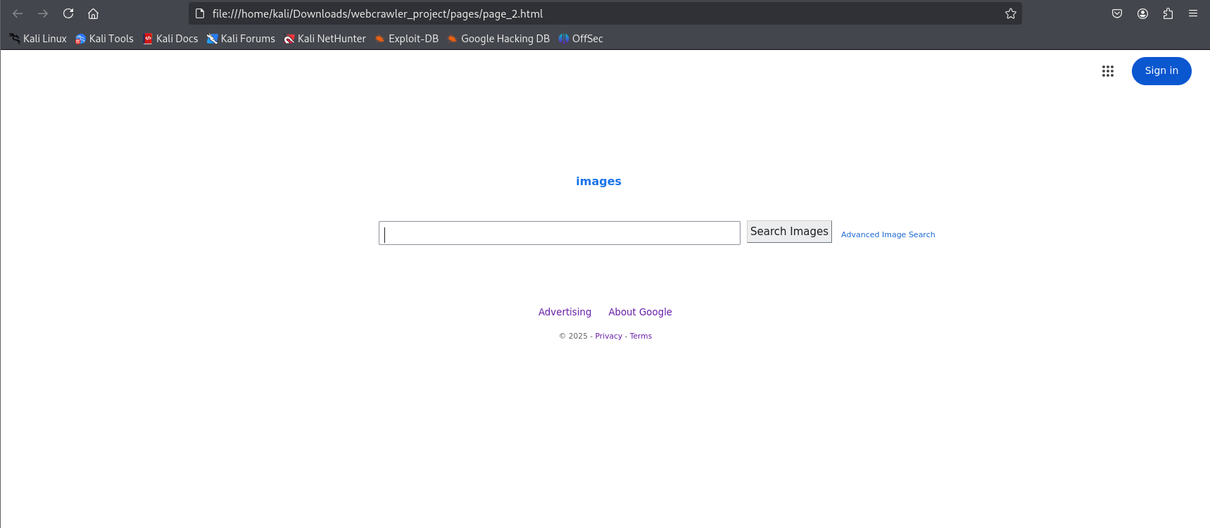
Figure 2 Sub-category page showing successful link extraction and navigation.

Page_3.html
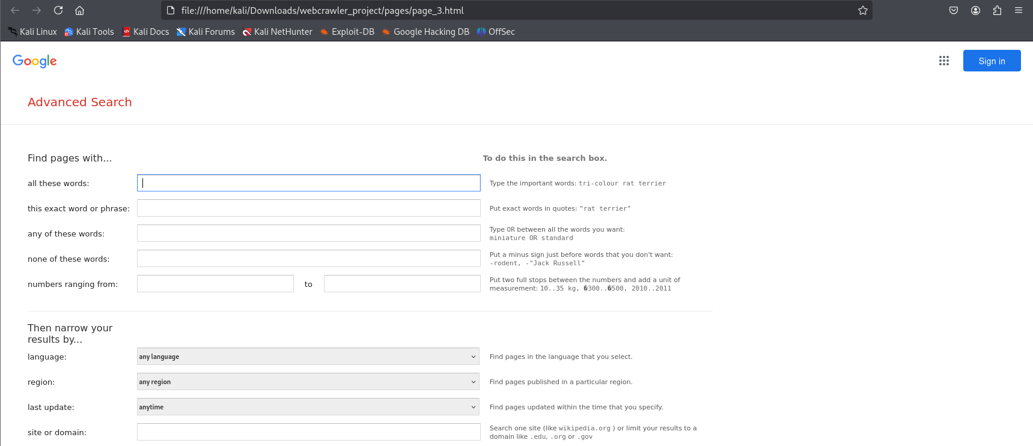
Figure 3 Proves parser successfully extracted and joined relative links to expand crawl frontier beyond seed page.

Page_23.html

Figure 4 Proves the crawler stopped correctly at the limit.

Directory View
Figure 5 Directory view of the /pages folder containing all 23 retrieved HTML documents.

Error Scenario
This screenshot demonstrates how the system handles a 'DNS Lookup Failure.' When an invalid URL is provided, the worker thread identifies the empty response from the CURL module. Instead of crashing the parallel system, the thread logs the event, updates the statistics, and allows the orchestrator to perform a clean shutdown.
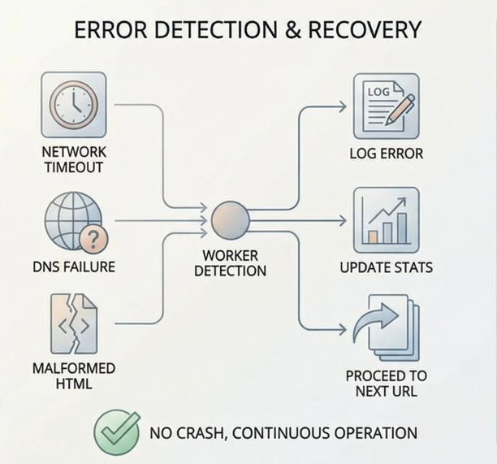
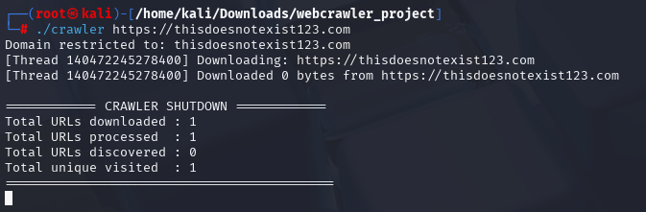
Even though it failed, the counter says 1 because the thread successfully attempted the task. The crawler.log file contains more specific error message from the attempt.
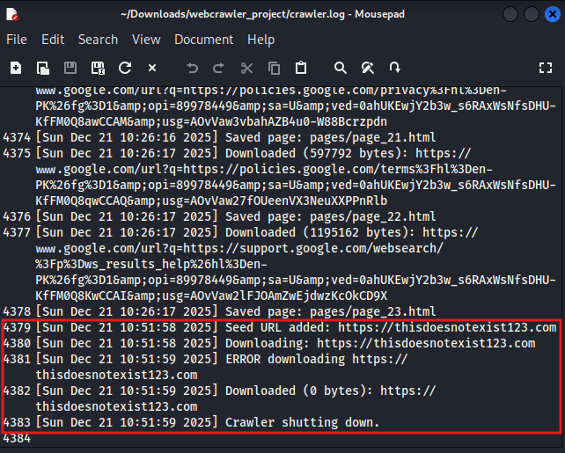

Conclusion
This project successfully demonstrates the power of parallel computing in network-bound tasks. By using threads, we were able to process 20 pages in a fraction of the time it would take a serial program. The implementation of mutexes and condition variables provided a deep understanding of thread synchronization and the challenges of shared-memory programming.

